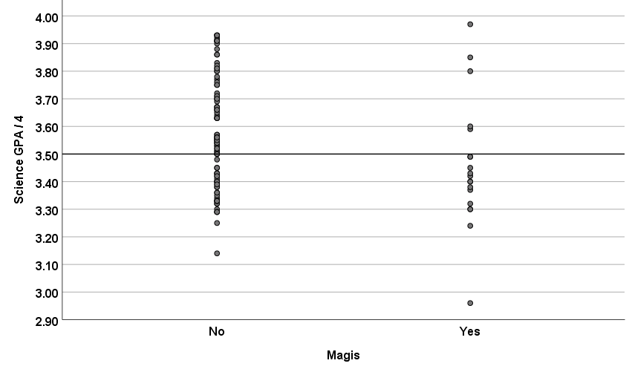

Sci GPA * Magis Crosstabulation
 |  |  | Magis |  | Total
 |  |  | No | Yes
Sci GPA | 3.5 or less | Count | 37 | 14 | 51
 |  | % | 72.5% | 27.5% | 100.0%
 | Over 3.5 | Count | 64 | 5 | 69
 |  | % | 92.8% | 7.2% | 100.0%
Total |  | Count | 101 | 19 | 120
 |  | % | 84.2% | 15.8% | 100.0%

Sci GPA | N | Referred |  | Percent | Difference | Z | P Value | 95% CI
≤ 3.5 | 51 | 14 | 27.5 |  | 20.3 | 3.00 | .003 | 6.5-33.9
> 3.5 | 69 | 5 | 7.2

