Main Theme – It’s hard to analyze videos. There’s a lot to consider. Projectile Motion: a_{x}=0, a_{y} = -9.8m/s²
Activity 1
  - Setting up the video and Logger Pro
1.1.1 - Open Logger Pro then Select the INSERT TAB then “Movie”. DO NOT go to File->open. wwwCourseInfoSC123Table1samash.mp4
1.1.2 - Select the Data table on the left. Press Delete key to delete table
1.1.3 - Click on the PAGE tab then choose AutoArrange
1.1.4 - Select the video image and drag the bottom right corner down to enlarge video as much as possible.
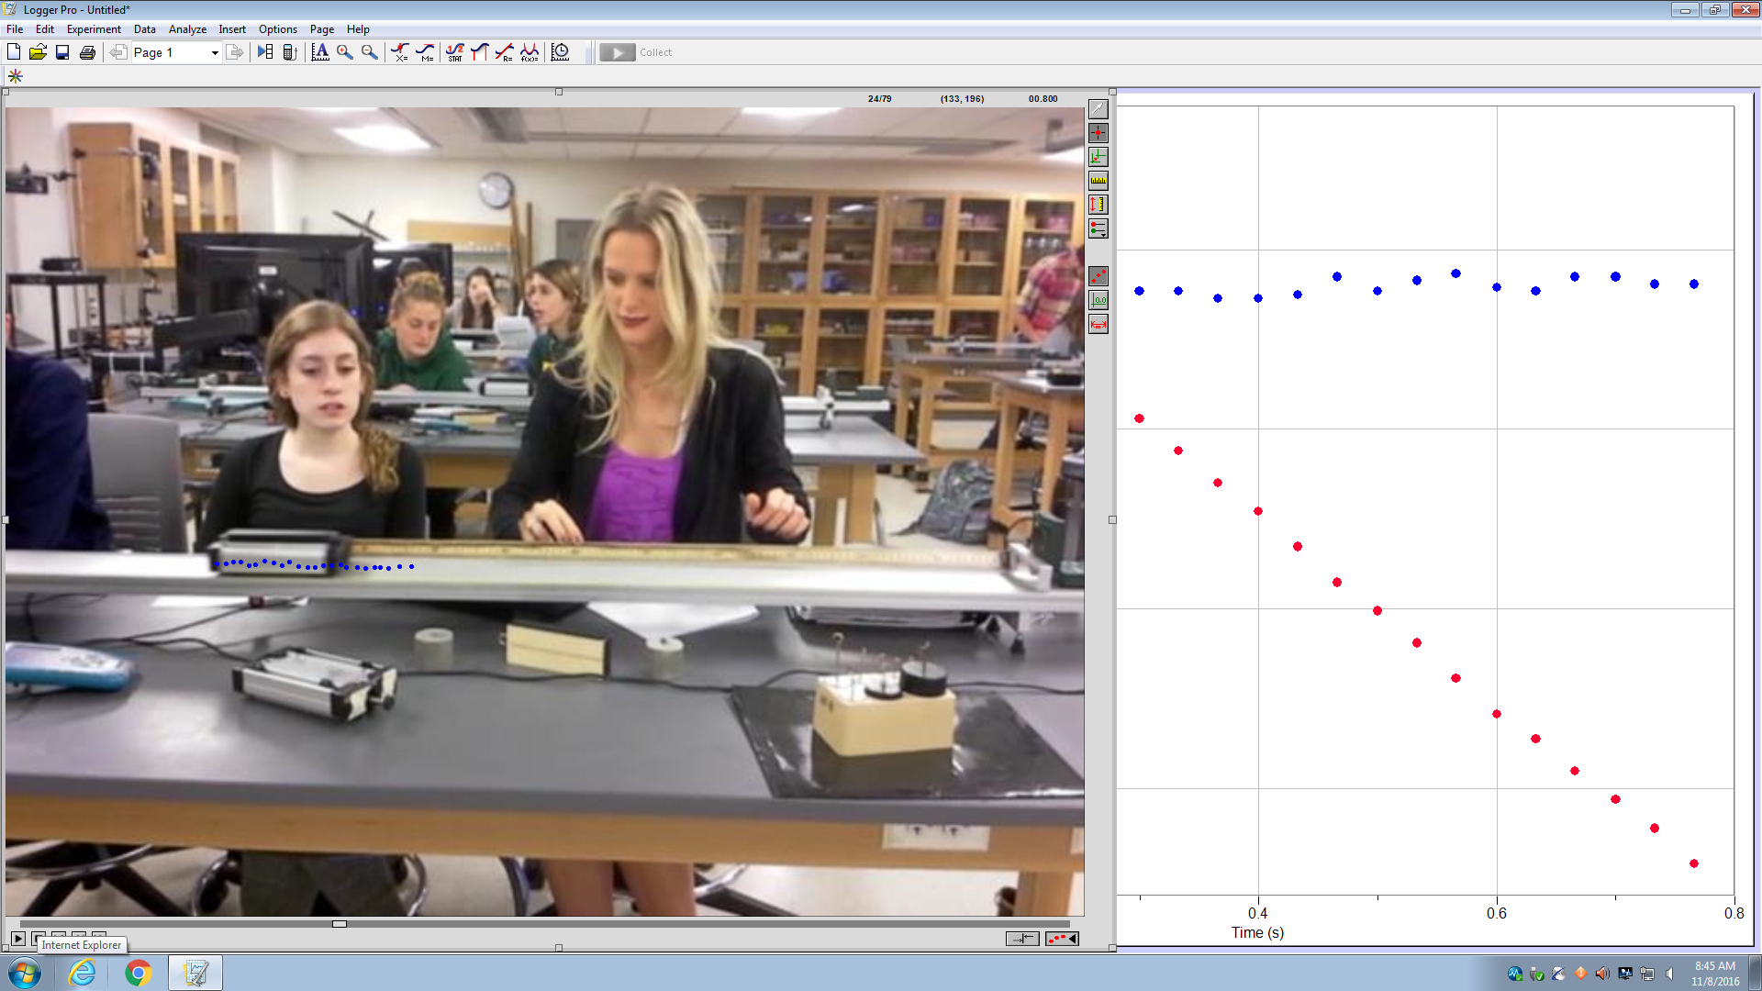
1.4 DO NOT PLAY THE MOVIE WHEN CLICKING ON THE CART! CLICK ON THE SAME POINT ON THE CART EACH FRAME. Make sure video is at start BEFORE CLICKING To do this, drag narrow slider bar above the play button all the way to the left. Use CTRL-Z if you need to go back a step or DATACLEAR ALL DATA

The “constant” set of pixels is the position in the vertical (y-dir) direction. If the cart is not jumping off the track, the vertical position of the cart will be constant.
The “sloped” set of pixels is the position in the right-left horizontal (x-dir) direction. If the cart is moving to-the-RIGHT, the velocity is POSITIVE. If the cart is moving to-the-left, the velocity is negative.

1.5 Click on the Logger Pro graph to see the entire graph. Make it big.
Q1 –Click on the ANALYZE tab. Choose linear fit “VideoAnalysis| X” (sloped graph). Make sure it’s a good fit.
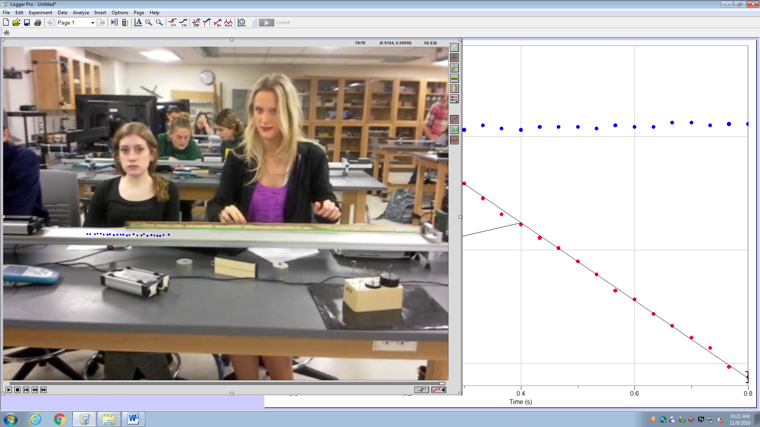
Q1 - X and Y values are in pixels. Different groups may get different values for un-scaled graphs due to different sizes of the video on the screen. ANSWER THIS QUESTION BEFORE GOING ON TO 1.6
1.6 Click on the REWIND BOTTON ON THE GRAPH BAR of the video to see all of it. Try not to click on the video. If you click on the video, an additional data point may be added. If it is, press CTRL-Z to remove it. DRAG THE GREEN LINE FROM ONE END OF THE METER STICK TO THE OTHER END OF THE METER STICK.

1.8 – Every group should get the same x-dir velocity after scaling. (Q4)
SHOW THE INSTRUCTOR THE GRAPH of X,Y vs Time with fit of x-data. Go to FILE tab the choose PRINT GRAPH
Q5 – Watching the “samash.mp4” video … To do this, note the direction the cart moves and “eyeball” (estimate) the distance to cart moves during the video. Hint: there’s a meter stick in the video. Also estimate the duration of the video (say “1000-one” “1000-two” “1000-three”… or use a clock while playing the video).
Activity 2: Your instructor may have a video already made for you to analyze.
2.1 See top of page 5: Figure 1
2.5 You will make a video of a basketball being tossed between partners. Orient camera wide-edge horizontal.
2.7 e-mail the video to yourself then download it to yourself. It will probably end up in the DOWLOADS folder
2.8 – Show the graphs to the instructor. Click on the graph. Go to FILE tab and choose PRINT GRAPH
Q10, Q11, Q12, Q13 – Make sure you convert you scale to METERS. Answers are in meters, m/s, m/s², …
3. – You may be required to analyze additional videos and hand in your work. Ask your instructor.

