Question: Can we use videos to analyze motion?
Introduction: Videos are created by taking still-frame snapshots of objects at constant time intervals several times per second. These snapshots, called frames, are played back recreating the objects’ motion. Digital videos can be re-played frame by frame and analyzed. However, the analysis becomes complicated if the camera is moving or the objects are moving toward or away from the camera. The analysis can be simplified if a video is created with a stationary camera and an object that remains at the same distance from the camera.
In this case, the video can be analyzed if the following are known:
- frames per second (fps) or the inverse: time between frames, known as the frame rate
- a known distance or size at the same distance as the object being analyzed
Normally, the frame rate of a video is 1/30sec or 30 frames per second (fps). However, time lapse video is created using a slower frame rate while slow motion video is created using a higher frame rate. In this way, playing back the video at the normal 30fps, objects will move faster or slower than they actually did.

When analyzing graphs of position vs time, the slope of the position is the velocity.
The overall velocity (speed), $V= \sqrt{V_{x}^{2}+V_{y}^{2}}$
Quick estimate of the spread of a data set: the standard deviation, σ ≈ (Highest value – Lowest value) / 4

PART 1 – Wildebeest Speed
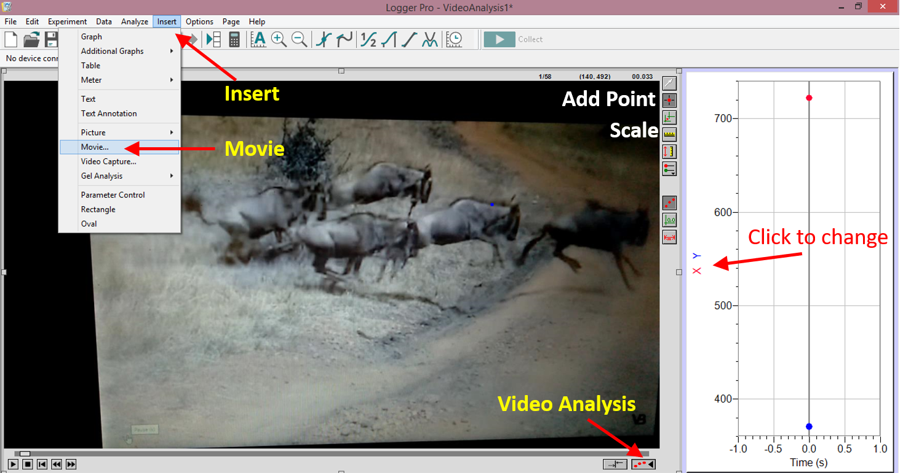
- Look at the image above. It is a snapshot of the LoggerPro software application with a video inserted. Various options are pointed out which will be helpful when using the software to analyze videos.
- Start Logger Pro and load “VideoAnalysis1Positions.cmbl” (File Tab Open)
- See the figure above for help. Insert (NOT File/open) the movie Wildebeest-shoulderHeight4_5ft.mp4
- Expand the size of the video as large as possible without covering the graph.
- Play the video and reset it to the beginning.

You will collect position vs time data from the video.
- See the figure above. Enable Video Analysis. The “Add Point”, “Scale”, and other icons will become visible.
- Click on “Add Point”. See the figure above.
- Locate a point on a wildebeest that is moving in the video and click on it. A dot should appear, and the video will advance one frame.
- Continue clicking on the same point of the same wildebeest as it moves frame by frame.
(turn the page for more)
You need to create a scale on the video to get the actual distances.
- Click on the “Scale” icon. See the figure above.
- To create the scale, you must know an actual distance in the video. Click and drag on the video along the distance you know or can determine. Enter the actual distance with units in the window that pops up.
HINT: You can use the internet.

You will find the velocity of the wildebeest that you clicked on and tracked.
- Your graph be set with the y-axis on the graph as X-Position and Y-Position. See the figure above for help.
- Find the mean velocity by
  - Highlighting the “relatively straight-line” velocity region of your data
  - Selecting the “Analyze” drop-down
  - Choosing “linear fit”.
- Does your velocity seem reasonable? Did you use both x and y velocities? Do you need both velocities? How accurate is your value? Did you check by comparing your measured speed with internet values?
- Re-do all the measurements a couple times to understand how repeatable your values are. You can use DATAClear All Data in LoggerPro to clear the dots.

Trial | X Velocity in meters/sec | Y Velocity in meters/sec | Overall Velocity (m/s)
1
2
3
Average Velocity

Average speed of a wildebeest in this video in miles per hour ________________MPH
Estimated spread (standard deviation) of this wildebeest overall velocity __________ MPH
(see Introduction on page 1). This is an estimate of the error encountered collecting the data. Generally, 2/3 of your measurements will be within the average speed ± one standard deviation.

A relatively small spread (standard deviation) compared to the average implies the data was consistent and “easy-to-repeat”. A relatively large spread implies the data collection was prone to inaccurate, “hard-to-measure” measurements.
Example 1: average = 100, spread = 1. The standard deviation, σ, is only 1% of the average implying the results were “easy-to-repeat”.
Example 2: average = 100, spread = 30. The standard deviation, σ, is 30% of the average implying a large spread in results and that the experimental measurements had large inaccuracies.
Are your results very repeatable? Why or why not? _________________________________ ____________________________________________________________________________

Hoes does your overall velocity value compare to other groups? ______________________
____________________________________________________________________________
____________________________________________________________________________
PART 2: Apparent speed of the moon. READ IMPORTANT CHANGES BELOW
- Close LoggerPro. Restart LoggerPro and load “VideoAnalysis1.cmbl”
- Insert the movie “Moonrise-D3475kmTL90s.mp4”. See the Wildebeest figure above for help.
- Expand the size of the video as large as possible without covering the graph.
- Play the video and reset it to the beginning.

You will collect position vs time data from the video.
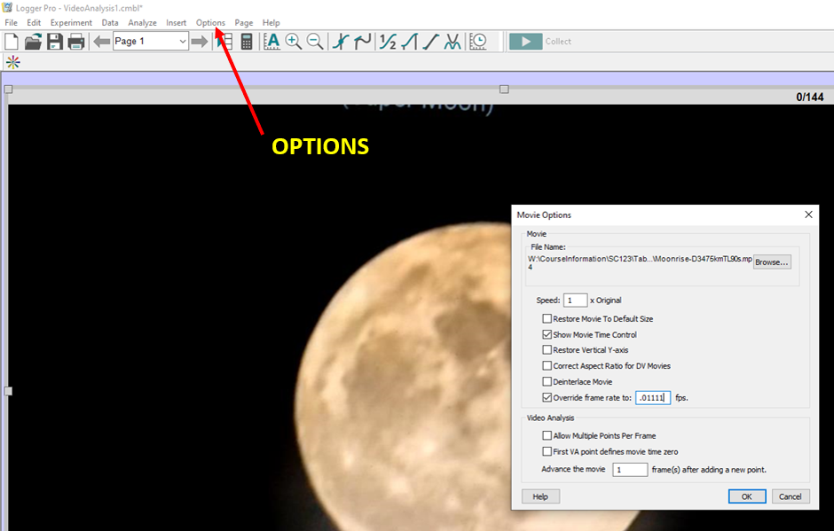

- Enable Video Analysis. The “Add Point”, “Scale”, and other icons will become visible.
- IMPORTANT: This is a time-lapsed video with a frame rate of 90 sec per frame or 0.01111fps. Click on the Moon then choose the “OPTIONS” tab and “Movie Options”. Check “Override frame rate to: “. Enter 0.01111 See the figure above. Click OK.
- Click on “Add Point”. See the Wildebeest figure for help.
- Locate one point of the Moon and click on it.
- Continue clicking on the same point of the Moon as it moves.

You will scale the video to get the actual distances between positions.
- Click on the “Scale” icon.
- To create the scale, you must know an actual distance in the video. Click and drag on the video along the known distance. Enter the actual distance with units in the pop-up window. HINT: You can use the internet.
IMPORTANT: Find the known size in km and set the scale units to km.
(turn the page for more help)

You will find the apparent velocity of the Moon.
- The y-axis on the graph should be set to X-Position and Y-Position.
- Find the mean velocity by
  - Highlighting all of your data of the Position vs Time graph.
  - Selecting the “Analyze” drop-down
  - Choosing “linear fit”
- It may be best when comparing to convert the velocity from km/s to km/hr. There are 3600sec/hr. Does your velocity seem reasonable? Did you use both x and y velocities? Do you need both velocities? How accurate is your value? Did you check by comparing your measured speed with internet values?
HINT: What velocity did you actually measure? Does the Moon actually move westward each day?
HINT: the radius of the Earth is 6378km at the equator.
- Re-do all the measurements a few times to understand how repeatable your values are.

Trial | X Velocity in km/sec | Y Velocity in km/sec | Overall Velocity (km/s)
1
2
3
Average Velocity

Apparent speed of moonrise in this video in km per HOUR____________________ km/Hr
Estimated spread (standard deviation) of this moonrise overall velocity _________ km/hr
(see Introduction on page 1). This is an estimate of the error encountered collecting the data. Generally, 2/3 of your measurements will be within the average speed ± one standard deviation.

What velocity did you actually measure You can use the internet to compare values? Explain _______________________________________________________________________________________
___________________________________________________________________________
___________________________________________________________________________
___________________________________________________________________________

PART 3: Speed of a Golf ball. READ IMPORTANT CHANGES BELOW
- Close LoggerPro. Restart LoggerPro and load “VideoAnalysis1Positions.cmbl”
- Insert the movie “Tiger_Woods_5_iron_180fps_Slow_motion.mp4”. See the Wildebeest figure above for help.
- Expand the size of the video as large as possible without covering the graph.
- Play the video and reset it to the beginning.

You will collect position vs time data from the video.
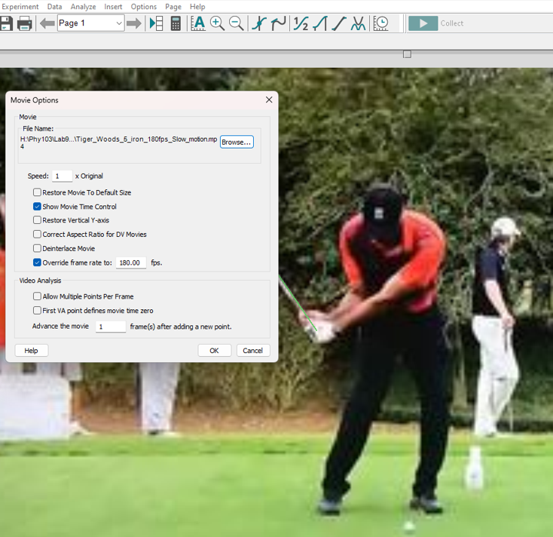

- Enable Video Analysis. The “Add Point”, “Scale”, and other icons will become visible.
- IMPORTANT: This is a slow-motion video with a frame rate of 180 fps. Click on the video then choose the “OPTIONS” tab and “Movie Options”. Check “Override frame rate to: “. Enter 180. See the figure above. Click OK.
- Click on “Add Point”. See the Wildebeest figure for help.
- Play the video to the point just before the ball is hit. Pause the video and click on the ball.
- Continue clicking on the same point of the ball as it moves.

You will scale the video to get the actual distances between positions.
- Click on the “Scale” icon.
- To create the scale, you must know an actual distance in the video. Click and drag on the video along the known distance. Enter the actual distance with units in the pop-up window. HINT: You can use the internet or yourself. IMPORTANT: Find the known size in meters.
(turn the page for more help)

You will find the speed of a golf ball.
- The x-axis should be time, the y-axis Position-X, Position-Y.
- Find the velocity by
  - Highlighting all of your data in the straight-line region. There may be some horizontal parts but highlight the overall region where the dots average to a straight line.
  - Selecting the “Analyze” drop-down
  - Choosing “Linear fit”
- Does your velocity seem reasonable? Convert to miles-per-hour since we have a good feel for that speed. Did you use both x and y velocities? Do you need both velocities? How accurate is your value? Did you check by comparing your measured speed with internet values?
- Re-do all the measurements a few times to understand how repeatable your values are.

Trial | Slope in meters/sec | Speed in MPH
1
2
3
Average speed

Average speed of the ball in this video in Miles Per Hour ______________________________ MPH

Estimated spread (standard deviation) of this ball’s overall velocity __________ MPH
(see Introduction on page 1). This is an estimate of the error encountered collecting the data. Generally, 2/3 of your measurements will be within the average speed ± one standard deviation.

Do you think the speed of the ball is faster than the speed of sound? State the speed of sound in air and compare ________________________________________________________________________________________________
________________________________________________________________________________________________
________________________________________________________________________________________________
Did the account for the ball accelerating off the ground? How did this affect its motion? How can you determine this? ________________________________________________________________________________________________
________________________________________________________________________________________________
________________________________________________________________________________________________
________________________________________________________________________________________________

PART 4: Speed of fluid from a sneeze. READ IMPORTANT CHANGES BELOW
- Close LoggerPro. Restart LoggerPro and load “VideoAnalysis1Positions.cmbl”
- Insert the movie “Sneeze_10kFPS.mp4”. See the Wildebeest figure above for help.
- Expand the size of the video as large as possible without covering the graph.
- Play the video and reset it to the beginning.

You will collect position vs time data from the video.
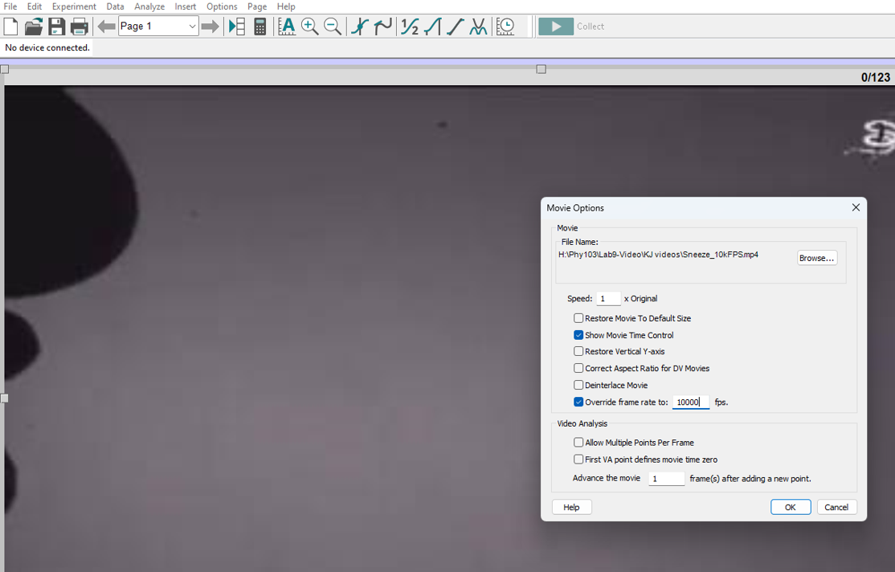

- Enable Video Analysis. The “Add Point”, “Scale”, and other icons will become visible.
- IMPORTANT: This is a slow-motion video with a frame rate of 10000 fps. Click on the nose then choose the “OPTIONS” tab and “Movie Options”. Check “Override frame rate to: “. Enter 10000. See the figure above. Click OK.
- Click on “Add Point”. See the Wildebeest figure for help.
- Locate one good glob of spit and click on it. Watch the video a few times to see the one that comes far out.
- Continue clicking on the same point of the glob as it moves. (It may be stationary for a couple frames. Just keep clicking)

You will scale the video to get the actual distances between positions.
- Click on the “Scale” icon.
- To create the scale, you must know an actual distance in the video. Click and drag on the video along the known distance. Enter the actual distance with units in the pop-up window. HINT: You can use the internet or yourself. A nose and mouth are in the picture. IMPORTANT: Find the known size in meters.
(turn the page for more help)

You will find the velocity of fluid from a sneeze.
- The x-axis should be time, the y-axis Position-X, Position-Y.
- Find the velocity by
  - Highlighting all of your data in the straight-line region. There may be some horizontal parts but highlight the overall region where the dots average to a straight line.
  - Selecting the “Analyze” drop-down
  - Choosing “Linear fit”
- Does your velocity seem reasonable? Convert to miles-per-hour since we have a good feel for that speed. Did you use both x and y velocities? Do you need both velocities? How accurate is your value? Did you check by comparing your measured speed with internet values?
- Re-do all the measurements a few times to understand how repeatable your values are.

Trial | Speed in meters/sec
1
2
3
Average speed

Average speed of fluid from a sneeze in this video in Miles Per Hour ______________________________ MPH

Estimated spread (standard deviation) of this spit overall velocity __________ MPH
(see Introduction on page 1). This is an estimate of the error encountered collecting the data. Generally, 2/3 of your measurements will be within the average speed ± one standard deviation.

From an internet search, what is the range of speeds of “spit” from a sneeze in MPH? ______________MPH
Were you values within the range given? If not, what may have been a reason why your values were not in the range.
________________________________________________________________________________________________________
________________________________________________________________________________________________________

Do you think the speed of fluid from a sneeze could break the sound barrier? That is, could fluid from your nose and mouth travel faster than the speed of sound? State the speed of sound in air and compare. ________________________________________________________________________________________________
________________________________________________________________________________________________
________________________________________________________________________________________________
________________________________________________________________________________________________
________________________________________________________________________________________________

PART 5: Car Crash
- Close LoggerPro. Restart LoggerPro and load “VideoAnalysis1Positions.cmbl”
- Insert the movie “North_Seattle_gas_pump_on_fire_after_being_hit_by_Uber.mp4”. See the Wildebeest figure above for help.
- Expand the size of the video as large as possible without covering the graph.
- Play the video and reset it to the beginning. Replay and stop the video when the car comes in to view from the left.

You will collect position vs time data from the video.
- Enable Video Analysis. The “Add Point”, “Scale”, and other icons will become visible.
- Click on “Add Point”.
- Locate one point of the car and click on it. A dot should appear, and the video will advance one frame.
- Continue clicking on the same point of the car as it moves. It may be stationary for a few clicks – just keep clicking the same spot on the car.

You will need to create a scale on the video to get the actual distances between positions.
- Click on the “Scale” icon.
- To create the scale, you must know an actual distance in the video. Click and drag on the video along the known distance. Enter the actual distance with units in the pop-up window. HINT: You can use the internet.

You will find the velocity of the car.
- The graph x-axis should be time, the y-axis should be X-Position and Y-Position.
- Find the velocity by
  - Highlighting the straight-line region of your data (It may have some steps in it but overall should be a straight line)
  - Selecting the “Analyze” drop-down
  - Choosing “Linear fit”
- Does your velocity seem reasonable? Did you use both x and y velocities? Do you need both velocities? How accurate is your value? Did you check by comparing your measured speed with internet values?
- Re-do all the measurements a few times to understand how repeatable your values are.

Trial | Slope in meters/sec | Speed in MPH
1
2
3
Average speed

Average speed of the car in this video in Miles Per Hour ______________________________ MPH

Estimated spread (standard deviation) of this car’s overall velocity __________ MPH
(see Introduction on page 1). This is an estimate of the error encountered collecting the data. Generally, 2/3 of your measurements will be within the average speed ± one standard deviation.

PART 6: Corn Snake slithering
- Close LoggerPro. Restart LoggerPro and load “VideoAnalysis1Positions.cmbl”
- Insert the movie “SnakeMotion.mp4”. See the Wildebeest figure above for help.
- Expand the size of the video as large as possible without covering the graph.
- Play the video and reset it to the beginning.

You will collect position vs time data from the video.
- Enable Video Analysis. The “Add Point”, “Scale”, and other icons will become visible.
- Click on “Add Point”.
- Locate one point of the snake and click on it. A dot should appear, and the video will advance one frame.
- Continue clicking on the same point of the snake as it moves.

You need to create a scale on the video to get the actual distances
- Click on the “Scale” icon.
- To create the scale, you must know an actual distance in the video. Click and drag on the video along the known distance. Enter the actual distance with units in the pop-up window. HINT: You can use the internet. The snake is a corn snake.

You will find the velocity of the CORN snake.
- The y-axis on the graph should be set to X-Position and Y-Position.
- Find the velocity by
  - Highlighting the “relatively straight line” region of your X-Position data
  - Selecting the “Analyze” drop-down
  - Choosing “Linear fit”
- Does your velocity seem reasonable? Did you use both x and y velocities? Do you need both velocities? How accurate is your value? Did you check by comparing your measured speed with internet values? Note: Velocity can be positive or negative or zero. Did you collect enough points?
- Re-do all the measurements a few times to understand how repeatable your values are. You can use DATAClear All Data in LoggerPro to clear the dots.
Trial | X Velocity in meters/sec | Y Velocity in meters/sec | Overall Velocity (m/s)
1
2
3
Average Velocity

Average speed of this snake in Miles Per Hour ____________________________MPH
Describe the X-velocity ________________________________________________________
____________________________________________________________________________
Describe the Y-velocity. Is it ok to use an average for the Y-velocity? Explain _____________ ____________________________________________________________________________
____________________________________________________________________________
Compare the snake speed to a human sprinting speed and walking speed. Can you out-run or out-walk this snake? _______________________________________________________
PART 7: Speed of a Bullet Through Watermelon. READ IMPORTANT CHANGES BELOW
- Close LoggerPro. Restart LoggerPro and load “VideoAnalysis1Positions.cmbl”
- Insert the movie “BulletThruMelon10kFPS.mov”. See the Wildebeest figure above for help.
- Expand the size of the video as large as possible without covering the graph.
- Play the video and reset it to the beginning.

You will collect position vs time data from the video.
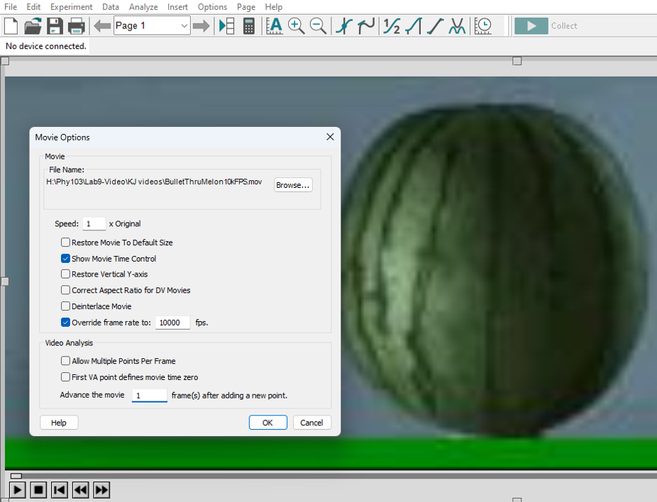

- Enable Video Analysis. The “Add Point”, “Scale”, and other icons will become visible.
- IMPORTANT: This is a slow-motion video with a frame rate of 10000 fps. Click on the melon then choose the “OPTIONS” tab and “Movie Options”. Check “Override frame rate to: “. Enter 10000. See the figure above. Click OK.
- Click on “Add Point”. See the Wildebeest figure for help.
- Locate bullet when it first comes in from the left and click on it.
- Continue clicking on the same point of the bullet as it moves. (It may be stationary for a couple frames. Just keep clicking). What do you do when it’s in the melon? Can you continue to get points after it comes out?

You will scale the video to get the actual distances between positions.
- Click on the “Scale” icon.
- To create the scale, you must know an actual distance in the video. Click and drag on the video along the known distance. Enter the actual distance with units in the pop-up window. HINT: You can use the internet or yourself. IMPORTANT: Find the known size in meters.
(turn the page for more help)

You will find the speed of a bullet.
- The x-axis should be time, the y-axis Position-X, Position-Y.
- Find the velocity by
  - Highlighting all of your data in the straight-line region. There may be some horizontal parts but highlight the overall region where the dots average to a straight line.
  - Selecting the “Analyze” drop-down
  - Choosing “Linear fit”
- Does your velocity seem reasonable? Convert to miles-per-hour since we have a good feel for that speed. Did you use both x and y velocities? Do you need both velocities? How accurate is your value? Did you check by comparing your measured speed with internet values?
- Re-do all the measurements a few times to understand how repeatable your values are.

Trial | Slope in meters/sec | Speed in MPH
1
2
3
Average speed

Average speed of the bullet in this video in Miles Per Hour ______________________________ MPH

Estimated spread (standard deviation) of this bullet’s overall velocity __________ MPH
(see Introduction on page 1). This is an estimate of the error encountered collecting the data. Generally, 2/3 of your measurements will be within the average speed ± one standard deviation.

Do you think the speed of the bullet is faster than the speed of sound? State the speed of sound in air and compare ________________________________________________________________________________________________
________________________________________________________________________________________________
________________________________________________________________________________________________
Did the bullet passing through the melon affect its motion? How can you determine this? ________________________________________________________________________________________________
________________________________________________________________________________________________
________________________________________________________________________________________________
________________________________________________________________________________________________

PART 8: FLAME SPEED OF A BURNING MATCH READ IMPORTANT CHANGES BELOW
- Close LoggerPro. Restart LoggerPro and load “VideoAnalysis1Positions.cmbl”
- Insert the movie “MatchBurning2500fps.mp4”. See the Wildebeest figure above for help.
- Expand the size of the video as large as possible without covering the graph.
- Play video and reset it to the beginning. Replay and stop the video just before the match starts burning.

You will collect position vs time data from the video.
- Enable Video Analysis. The “Add Point”, “Scale”, and other icons will become visible. 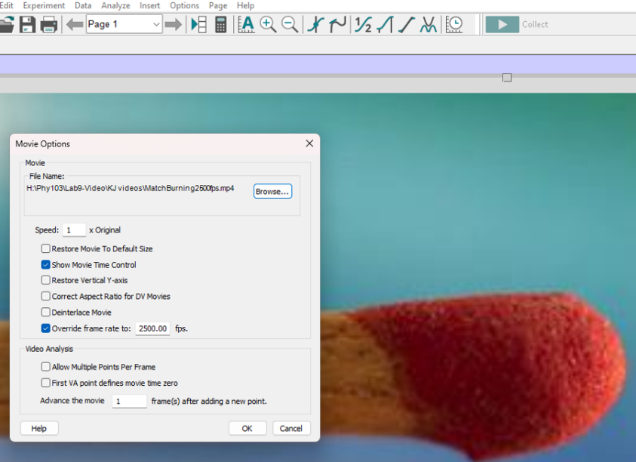
- IMPORTANT: This is a slow-motion video with a frame rate of 2500 fps. Click the match then choose the “OPTIONS” tab and “Movie Options”. Check “Override frame rate to: “.Enter 2500.See the figure above. Click OK.
- Click on “Add Point”.
- Locate the bottom of the match and click on it. A dot should appear, and the video will advance one frame.
- Continue clicking on the edge of the flame as it travels upward.

You will need to create a scale on the video to get the actual distances.
- Click on the “Scale” icon.
- To create the scale, you must know an actual distance in the video. Click and drag on the video along the known distance. Enter the actual distance with units in the pop-up window. HINT: You can use the internet. (turn the page for more info)

You will find the velocity of the flame.
- The graph x-axis should be time, the y-axis should be X-Position and Y-Position.
- Find the velocity by
  - Highlighting the straight-line region of your data.
  - Selecting the “Analyze” drop-down
  - Choosing “Linear fit”
- Does your velocity seem reasonable? Did you use both x and y velocities? Do you need both velocities? How accurate is your value? Did you check by comparing your measured speed with internet values?
- Re-do all the measurements a few times to understand how repeatable your values are.

Trial | Slope in meters/sec
1
2
3
Average speed

Average speed of the FLAME in this video in Meters Per Sec ______________________________ m/s

Estimated spread (standard deviation) of this flame’s overall velocity __________ m/s
(see Introduction on page 1). This is an estimate of the error encountered collecting the data. Generally, 2/3 of your measurements will be within the average speed ± one standard deviation.

