McClure Center
241 N Winooski Ave, Burlington, VT 05401

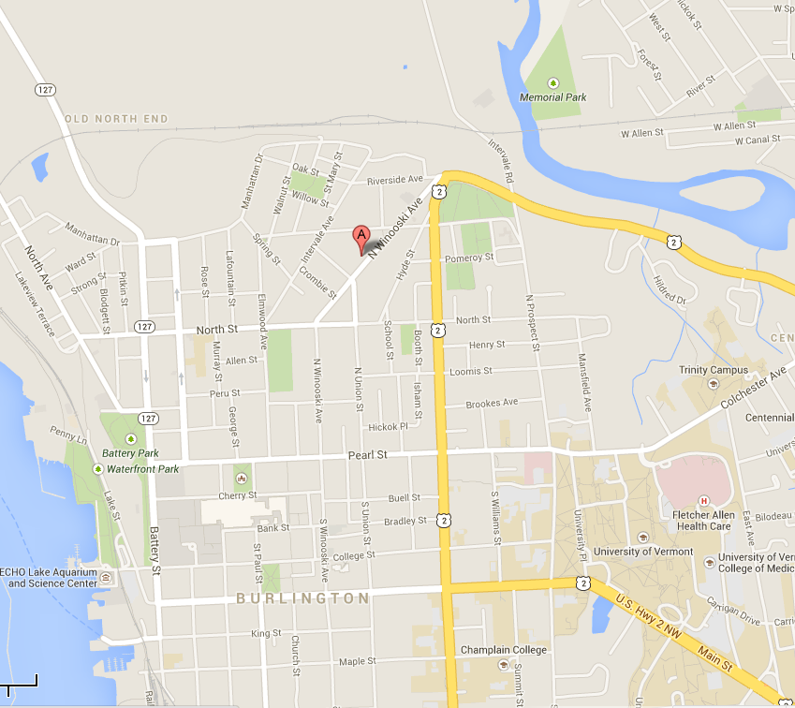

Albert Joy
91 Saint Louis St Burlington, VT 05401
802-310-8777

