- Turn left onto the Interstate 81 N ramp – go 0.2 mi total 1.8 mi

- Merge onto I-81 N About 25 mins – go 28.6 mi total 30.4 mi

- Take exit 16A for Interstate 481 N toward Dewitt – go 0.5 mi total 30.9 mi

- Merge onto I-481 N
About 8 mins – go 9.3 mi total 40.1 mi

- Take exit 6 to merge onto I-90 E Toll road
About 1 hour 30 mins – go 104 mi total 144 mi

- Take exit 27 for NY-30 toward Amsterdam Toll road
About 1 min – go 0.8 mi total 145 mi

- Keep right at the fork, follow signs for New York 5S/New York 30 N and merge onto NY-30 N
About 2 mins – go 1.0 mi total 146 mi

- Continue onto NY-67 E/Church St Continue to follow NY-67 E
About 24 mins – go 19.2 mi total 165 mi
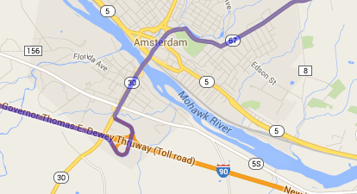

- Turn left onto Milton Ave – go 0.2 mi total 165 mi

- Take the 2nd right onto Malta Ave
About 6 mins – go 3.5 mi total 168 mi

- Turn left onto U.S. 9 N – go 0.5 mi total 169 mi

- Take the ramp onto I-87 N
About 22 mins – go 25.6 mi total 194 mi
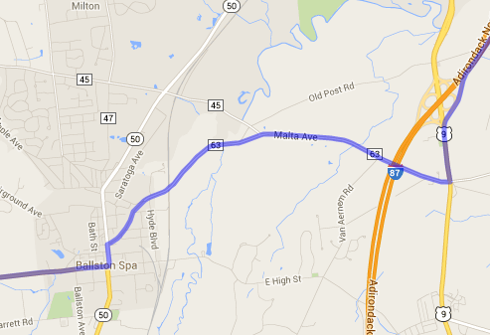

- Take exit 20 for NY-149 toward Fort Ann/Whitehall – go 0.1 mi total 195 mi

- Turn left onto NY-149 E/U.S. 9 N
About 1 min – go 0.5 mi total 195 mi
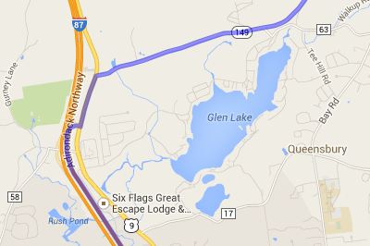

- Turn right onto NY-149 E
About 15 mins – go 11.7 mi total 207 mi

- Turn left onto US-4 N/George St Continue to follow US-4 N
About 13 mins – go 10.6 mi total 217 mi
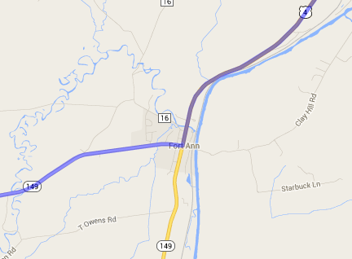

- Turn right onto US-4 N/Poultney St Continue to follow US-4 N Entering Vermont
About 10 mins – go 7.9 mi total 225 mi
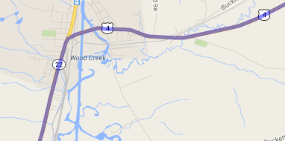

- Take exit 2 for Vermont 22A toward Fair Haven/Vergennes – go 0.3 mi total 226 mi
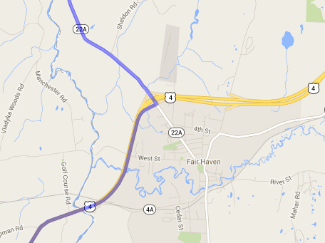

- Turn left onto VT-22A N
About 52 mins – go 41.9 mi total 267 mi

- Turn left onto US-7 N
About 29 mins – go 20.1 mi total 288 mi
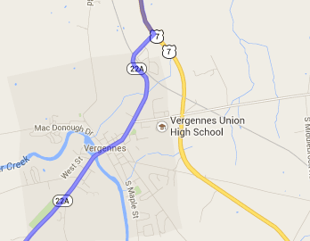

- Slight right onto S Willard St
About 2 mins – go 0.9 mi total 265 mi

- Slight left onto Main St
About 1 mins – go 0.3 mi total 265 mi
