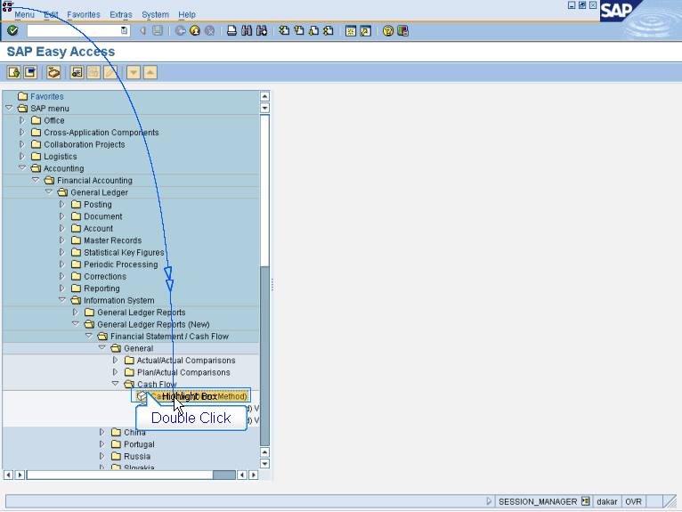

- Accounting > Financial Accounting
> General Ledger > Information System
> General Ledger Reports (New)
> Financial Statement/Cash Flow
> General > Cash Flow
Double Click Cash Flow (Direct Method)

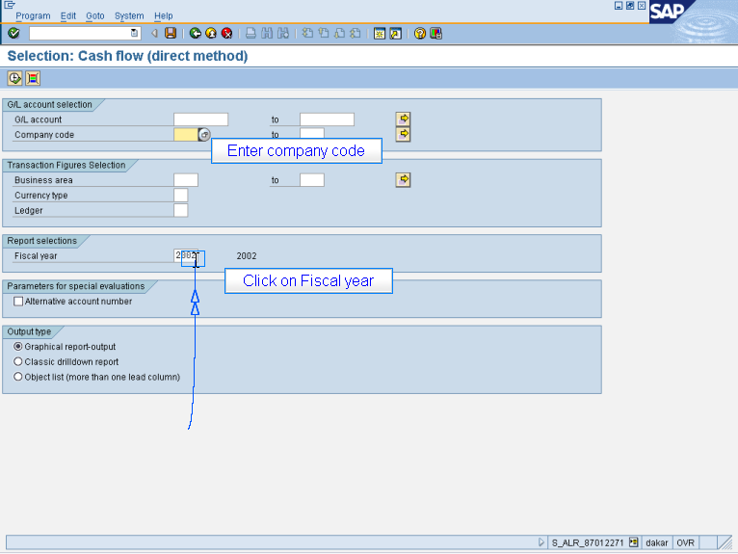

Enter company code
Click on Fiscal year

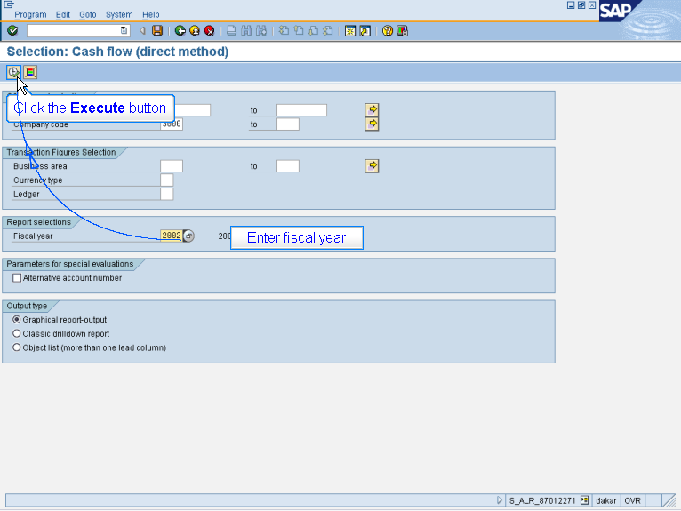

Enter fiscal year
Click the Execute button

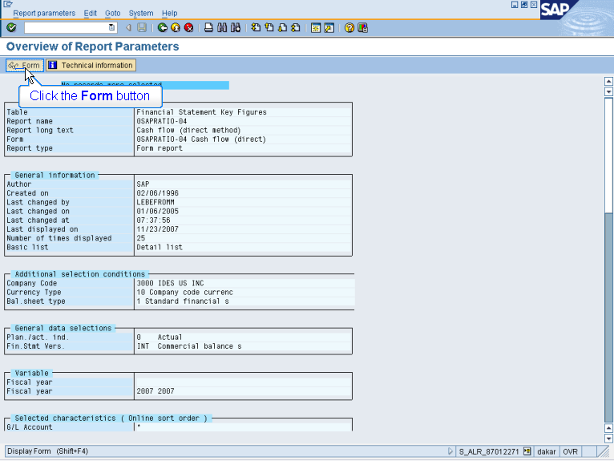

Click the Form button

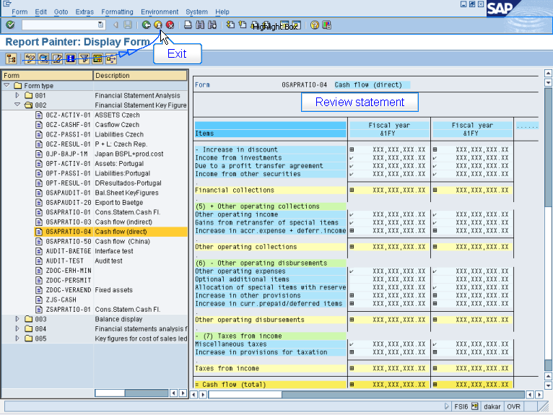

Review statement
Exit

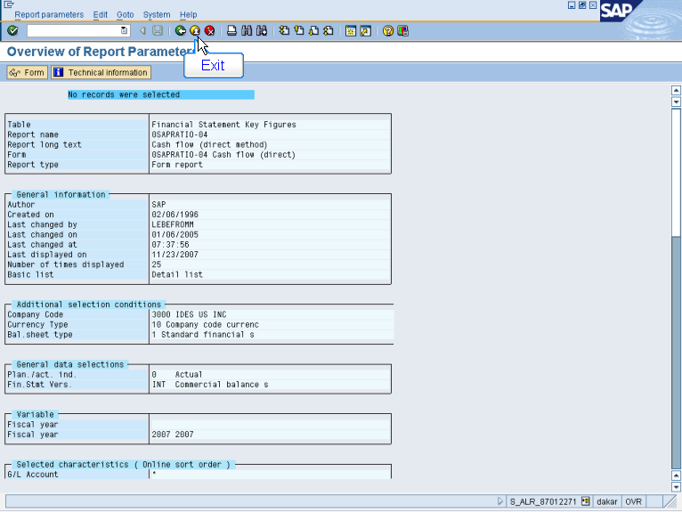

Exit

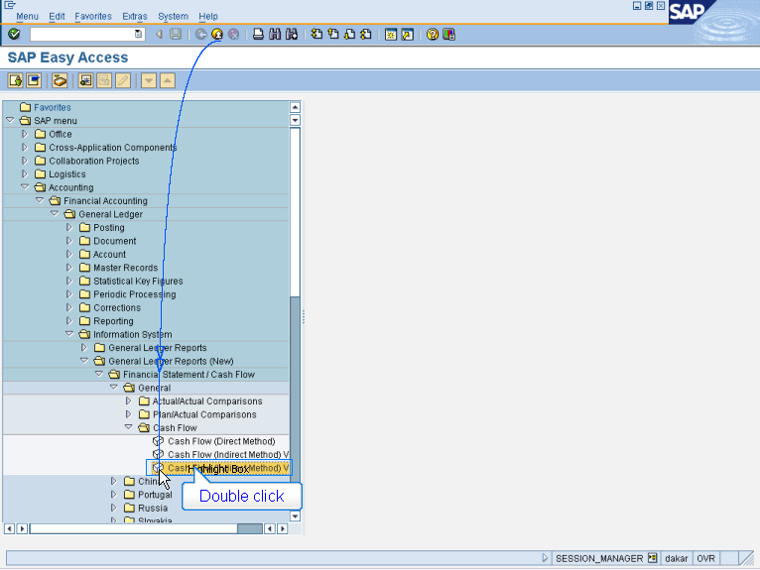

- Accounting > Financial Accounting
> General Ledger > Information System
> General Ledger Reports (New)
> Financial Statement/Cash Flow
> General > Cash Flow
Double Click Cash Flow (Indirect Method) Variant 2

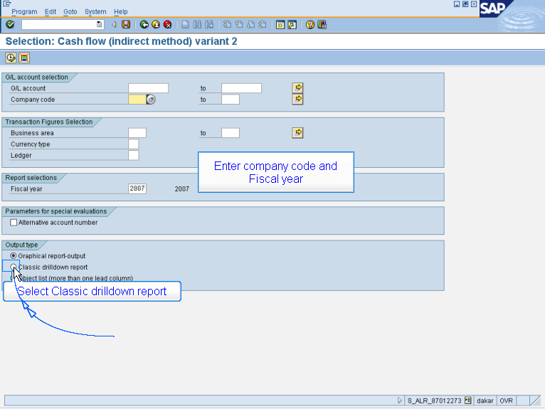

Enter company code and
Fiscal year
Select Classic drilldown report

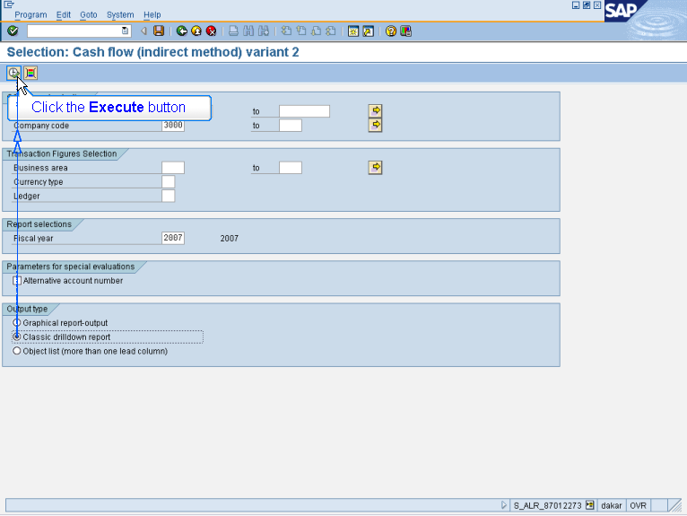

Click the Execute button

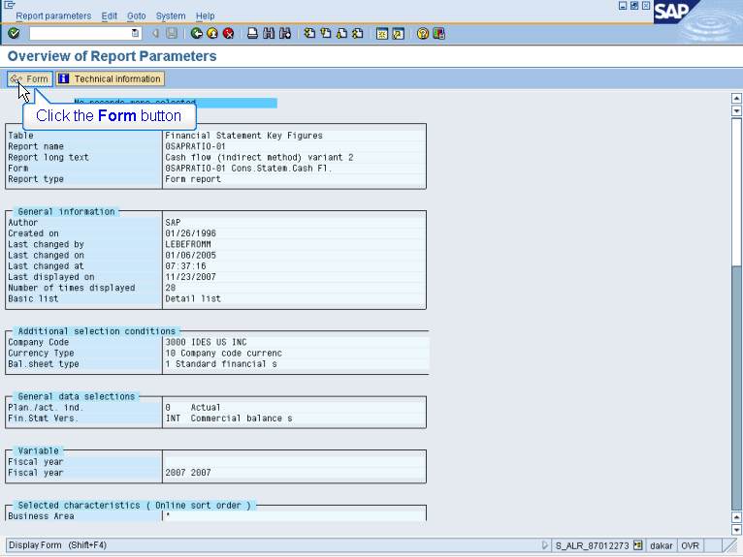

Click the Form button

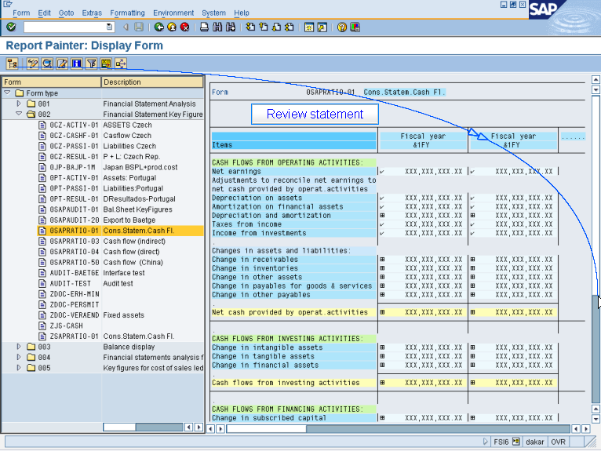

Review statement

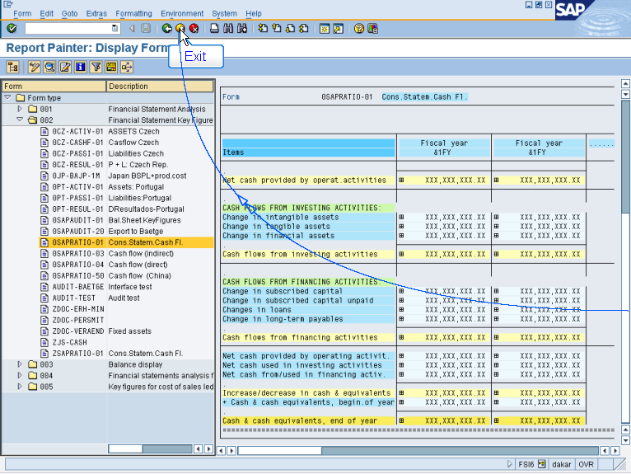

Exit

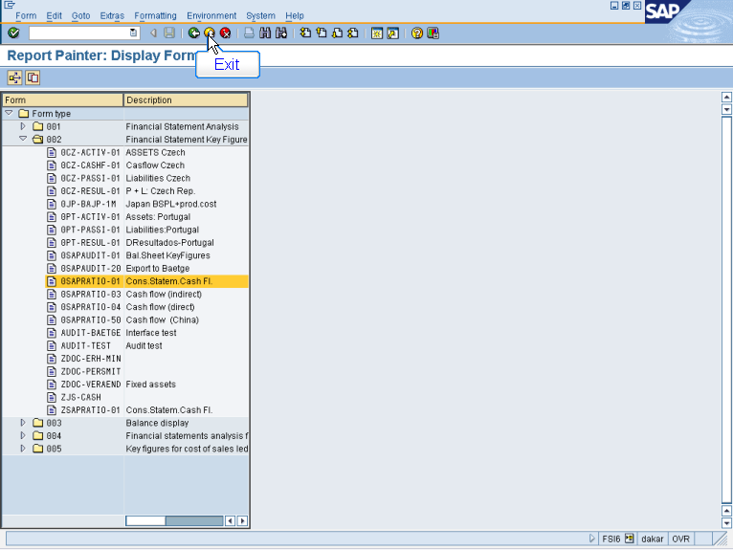

Exit

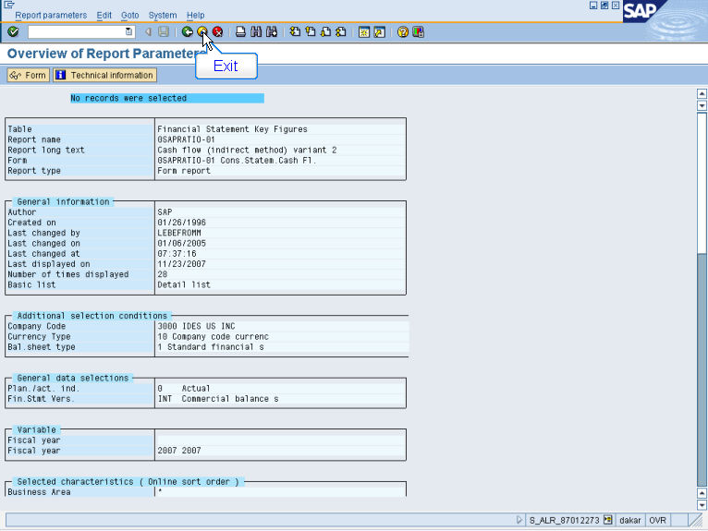

Exit



